Student’s name | …………………………………………………….…… | Grade | 5
Subject | Computer | Week No. | 10
Lesson Title | Smart Art, Hyperlinks in PPT | Unit
Worksheet No. ( 10 )
Question A: Fill in the blanks with the words in the box below. (P80)

Clouds | Rain | Rivers | Sea | Steam
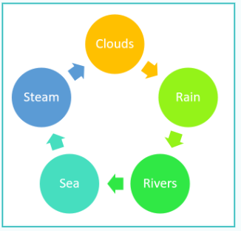
Good Luck
………………
………………
………………
………………
………………….

